4. Rewrite the BNF of Example 3.4 to add the ++ and -- unary operators

of Java.

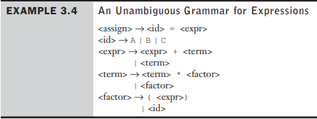

<assign> -> <id> = <expr>

<id> -> A | B | C

<expr> -> <expr> + <term>

| <term>

<term> -> <term> \* <factor>

| <factor>

<factor> -> (<expr>) | <id> | <id> ++ | <id> --

11. Consider the following grammar:

<S> → <A> a <B> b

<A> → <A> b | b

<B> → b

Which of the following sentences are in the language generated by this grammar?

a. babb

<S> -> <A> -> b -> ba -> ba <B> -> bab -> babb

b. bbbabb

<S> -> <A> -> <A> b -> <A> <A> b -> b <A> b -> bbb -> bbba -> bbba <B> -> bbbab -> bbbabb

~~c. bbaaaaabc~~ – There’s no “c” in the grammar

~~d. aaaaaa~~  - There needs to be at least one “b” in the sentence

21. Using the virtual machine instructions given in Section 3.5.1.1, give an

operational semantic definition of the following:

a. Java do-while

Loop:

Statements;

b. Ada for

c. C++ if-then-else

d. C for

e. C switch

